SNP Quality Analysis Tool

User manual

For program version 3.2

SNP Quality Analysis Tool 1
User manual 1
For program version 3.2 1
Introduction 4
Quality tests 4
Duplicate test 4
Inheritance test (only available in individual mode) 4
Hardy-Weinberg test 5
Blank test 5
Homozygote test 5
Selecting a database 5
The main window 5
General menu items 6
File -> New Session 6
File -> Open Session 7
File -> Exit 8
Tools -> Compare Results 8
Tools -> Identify Items 11
Options -> Preferences 13
The session window 14
Special list features 15
Select all 16
Select from file 16
Reverse selection 16
Save all 16
Save selection 16
Copy all -> with column names 16
Copy all -> without column names 17
Copy selection -> with column names 17
Copy selection -> without column names 17
Experiments 17
The experiment menu 18
Duplicate test -> Show failed/Show passed/Show tested 19
Inheritance test -> Show failed/Show passed/Show tested/Show failed trios 19
Blank test -> Show failed/Show passed/Show tested 19
Homozygote test -> Show failed/Show passed/Show tested 19
Show all 19
Show N/A 19
Show details 19
Reject minority results 20
Set status 21
Result Items 21
Cutoff 22
The result item menu 22
Show All 23
Show N/A 23
Show details 23
Set status 23
Control Items 24
The control items menu 24
Show All 24
Show N/A 24
Show details 24
Set Status 25
Menu items connected to the active session 25
File -> Close Session 25
File -> Save Session 25
File -> Save Report 25
File -> Approve Session 26
View -> Show Results -> Table, Experiments in Rows 26
View -> Show Results -> Table, Experiment in Columns 26
View -> Show Results -> Pairwise, Approved Combinations 26
View -> Show Results -> Pairwise, All Combinations 27
View -> Show Marker Annotations 27
View -> Show Session Contents -> Plates 27
View -> Show Session Contents -> Working Sets 27
View -> Show Session Contents -> Detailed Filter 28
View -> Show Pending Status Changes 28
Tools -> Inspect Plates 28
Tools -> Pick Rerun Items 28
Options -> Session Settings 30
The session settings window 31
Item Report Unit 31
Experiment Report Unit 31
Inheritance and chromosomes 32
Frequencies 32
The plates window 32
The selection tab 32
The experiment success rates tab 33
The item success rates tab 34
The well success rates tab 34
Special toolbar buttons 34
Processing control toolbar buttons 34
Status submission toolbar buttons 35

Introduction
SNP Quality Analysis Tool is a program for performing quality controls on SNP genotype data. Each genotype result undergoes certain tests in the program, and depending on the outcome of the tests, the result is either regarded as passed or failed. Statistics showing the distribution between passed and failed results in each test is readily available, along with statistics such as allele frequency and distribution between homozygotes and heterozygotes.

If the user knows that certain results are wrong, he or she can manually reject those results. It is however not possible to change the genotype of a result, or approve a result which has been failed by a test.

The program can report the results either by sample or by individual (called item with a common name) and either by marker or by assay (called experiment with a common name), as determined by the setting for each open session. Since there can potentially be more than one sample from each individual, reporting the results by individual means that results from samples coming from the same individual are merged.

An open session can contain results from both control samples and result samples/individuals. The results from controls are not included in the result tables or reports, but are only present to undergo some of the quality tests.

Quality tests
There are five different quality tests which can be performed, depending on the type of data which the program is fed with.

Duplicate test
This test investigates if a sample or individual which has been genotyped more than once has consistent results.

Inheritance test (only available in individual mode)
When family relation information is present in the database for the investigated individuals, this test controls if the children’s genotypes are possible considering the genotypes of the parents. If one or more child genotypes in a family are detected as wrong, all results from the whole family are failed (the reason being that it is impossible to know which results are wrong and which are correct within the family). Note that the test is only performed for one generation (core family) at a time, even though there can be defined relationships between more than one generation. Furthermore, if the genotype for one of the parents is missing, the test is performed with the missing genotype regarded as any of the possible outcomes.

Only results which have passed the duplicate test are investigated in the inheritance test. The test can be performed both on results from controls in the inheritance control individuals group and on normal individuals.

Hardy-Weinberg test
This test is a χ² test on the deviation from the Hardy-Weinberg equilibrium in the experiment. Only results which have passed the duplicate tests and inheritance tests (if such tests are performed) are included.

Blank test
When investigated by this test, the results are regarded as passed if they have no genotype call (indicated by “N/A” in the program), or failed otherwise. The test is only performed on control samples from individuals in the blank control individuals group.

Homozygote test
Results investigated by this test are passed if they have a homozygous genotype and failed if they have a heterozygous genotype. Only results from samples belonging to individuals in the homozygote control individuals group with a genotype call are tested.

Selecting a database
The database connections are specified in the “SQATconnect.xml” file present in the same folder as the program. If more than one connection is specified in this file, the program will ask you to select which one of the databases to use upon startup.

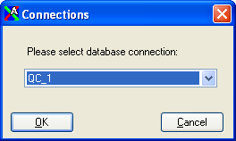

Figure 1 The “Connections” dialog is used to select a database connection when the program starts.

If only one connection is specified in “SQATconnect.xml”, the program automatically uses that connection.

The main window
After a database has been selected, the program shows its main window with indicators for the database name and the current user at the bottom. In this window, you can open up one or more session windows. A session is basically the combination of a data set and certain settings which define how the data set should be treated in the quality control steps.

General menu items
In the menu of the main window you can find menu items which are connected to the currently active session, as well as menu items which are not connected to a session. Below follows a description of the menu items not connected to any specific session.

File -> New Session
When this menu item is selected, a dialog opens where you can pick the plates and/or working sets which should be analyzed. Working sets can be combined to select only a subset of the data. Sets of the same type “add up” when combined, whereas working sets of different types exclude from each other. (E.g. when two plates are selected, all results in both plates are analyzed, whereas selecting one plate and one sample set means that only results from samples in the sample set which are also present in the plate are analyzed.)

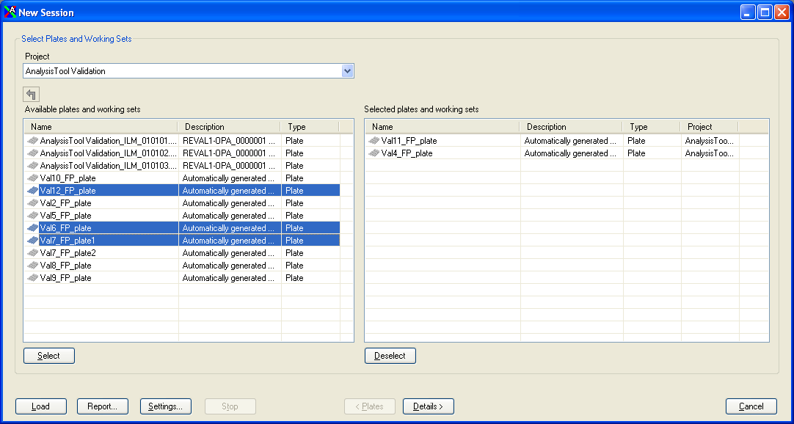

Figure 2 The “New Session” dialog is used for selecting plates and working sets to define the set of data which should be analyzed.

Clicking on the “Settings” button in the “New Session” dialog presents you with another dialog where you can change the session settings which should be applied when analyzing the data. Clicking on the “Details” button will allow you to further select samples/individuals and assays/markers among those present in the selected data sets.

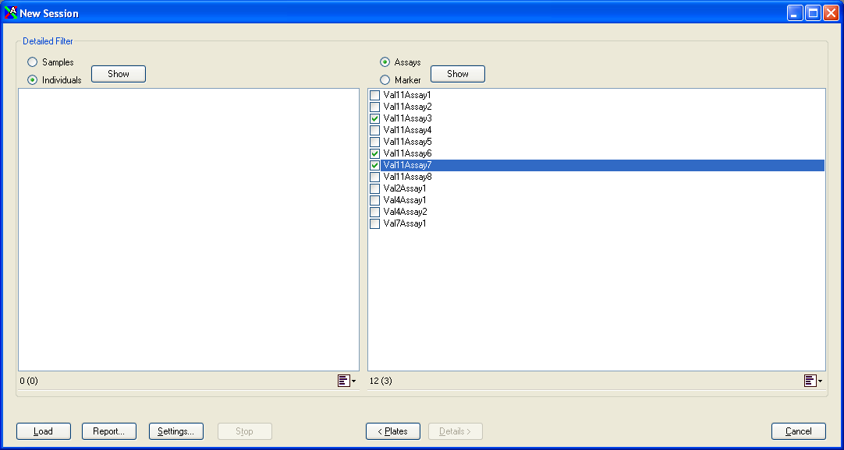

Figure 3 When the “Details” button is clicked, it is possible to individually pick samples/individuals or assays/markers among those included in the data set defined in the previous frame.

File -> Open Session
Select “Open Session” if you want to load an existing session which has been saved earlier. This menu item opens a dialog where you can browse among saved sessions. Only one session can be selected at the same time. Note that if you want to further limit the number of samples/individuals and assays/markers to be loaded, you can do that by clicking the “Details” button.

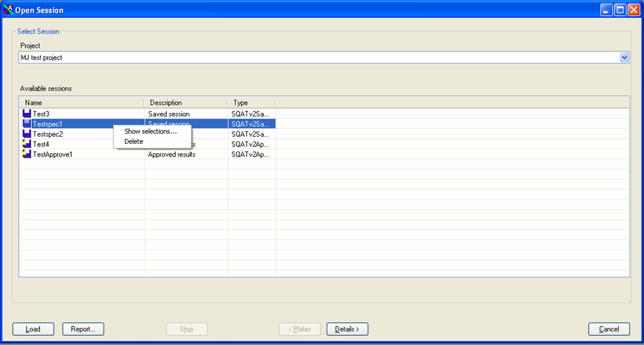

Figure 4 The “Open Session” dialog is used to open previously saved data sets and settings.

If you right-click on one of the existing sessions a menu appears where you can show which selections that were used in the saved session. Another menu alternative gives you the possibility to delete a saved session. If you right-click on an approved session and have this menu alternative activated in the configuration file, there is also an option for unlocking the session so that it can be changed again.

File -> Exit
When “Exit” is selected, all open sessions are closed and the program exits.

Tools -> Compare Results
By using this program feature, you can compare results from different sources including files and data sets from the database. When the menu option is selected, a window opens where you can choose from which sources you would like to compare data and which type of comparison that should be performed.

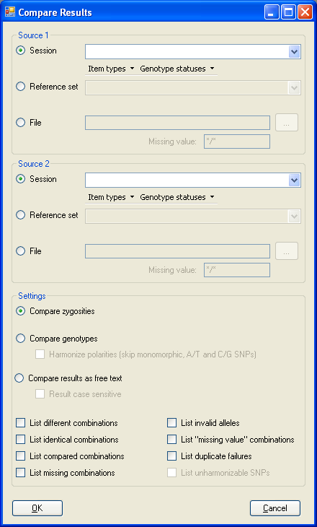
Figure 5 The Compare Results window.
Here is a table explaining the types of sources which can be selected:
Source type | Explanation
Session | A session opened either by using the File -> New Session menu option or the File -> Open Session menu option.
Reference Set | A special set of results present in the database for reference.
File | A tab-delimited text file containing item names in the first column, experiment names in the second column and the genotype in the third column with slash-delimited alleles (e.g. A/A or G/T).

The table below explains the comparison modes which can be selected:
Comparison mode | Explanation
Compare zygosities | If genotypes are homozygote or heterozygote in both sources they are regarded as equal. If they are homozygote in one source and heterozygote in the other source they are regarded as different. Please note that different homozygotes (such as C/C compared to X/X) or heterozygotes (such as A/C compared to G/T) are regarded as equal.
Compare genotypes | The genotypes need to match to be regarded as equal, except for the order and case of the alleles (e.g. C/t and T/c are regarded as equal).  If the “Harmonize polarities” check box is checked, the program attempts to flip results in the same direction so that a SNP genotyped on one strand can be compared to the same SNP genotyped on the other strand. However, it is not possible to discriminate the strands for A/T and C/G SNP types and for SNPs which are monomorphic in both the selected sources. Therefore, all such results are skipped when this check box is marked.
Compare results as free text | In this mode, the genotype results are compared just as they are without any attempt to interpret the results as alleles. By default the comparison is case insensitive. Check the “Result case sensitive” check box if you want to include case sensitivity in the comparison. The grouping of results on items and experiments are always case insensitive.

When “OK” is clicked, a report is generated containing information about the results of the comparison. Note that you can check the check boxes in the bottom of the “Settings” section first to include lists of genotypes or SNPs sorted out in the different categories in the report.

When the two sources are compared, a pre-scan is first performed to check which items and experiments are present in the first and second source. Only genotypes from items and experiments which are present in both sources are then processed further.

Below is a table explaining some of the figures in the report:
Figure | Explanation
No. compared genotypes | The number of genotypes which were actually compared in the end.
No. identical genotypes | The number of compared genotypes which were regarded as equal.
No. different genotypes | The number of compared genotypes which were regarded as different.
Difference | The percentage of compared genotypes which were regarded as different.
Total number of genotypes (after pre-scan) | The number of genotypes in each source after removal of genotypes from items or experiments not present in the other source.
No. valid unique item/experiment combinations | The number of genotypes after removal of any duplicates, missing value indications and invalid results. (See “No. invalid allele codes” for a further explanation of the latter).
No. missing value codes | The number of genotypes indicated with a missing value code.
No. invalid allele codes | The number of results not appropriate for the selected comparison mode. An example of an invalid result would be X/X in genotype comparison mode where A, C, T or G alleles are expected
No. item/experiment combinations with duplicate failures | The number of genotypes belonging to the same item and experiment in the same source and which are regarded as different. The same combination of item and experiment is counted only once irrespective of the number of duplicates.
No. genotypes in source x but not in source y (after pre-scan) | Genotypes belonging to items or experiments which are not at all present in the other source are removed in the so called pre-scan. After this removal, there can still be combinations of items and experiments which are only present in one source but not in the other. This figure states how many such genotypes that were removed from the comparison.
The following figures are only indicated when “harmonize polarities” is selected.
No. experiments with too many alleles in source x | The number of experiments for which more than two different alleles were found altogether in the same source. These experiments are removed from the comparison because the program requires that genotypes from the same source are from the same strand.
No. experiments monomorphic in both sources | The number of experiments with no variation in either of the sources. These experiments are removed from the comparison because it is not possible to know if genotypes from the two sources are from the same or different strands.
No. experiments with incompatible SNP types | The number of experiments for which the SNP type in one source is neither the same nor the complement of the SNP type in the other source. These experiments are removed from the comparison because it is not possible to convert the genotypes to one strand.
No. experiments with A/T and C/G SNP types | The number of experiments with an A/T variation or a C/G variation. These experiments are removed from the comparison because it is not possible to know which strand the genotypes come from since both alleles are the complement of the other.

After the report has been generated, it is possible to either copy the text or save the report in a text file by clicking on the “Save” button.

Tools -> Identify Items
This feature can be used to compare genotype results from one item against those of all other items and see how well they match. It is possible to try to match one specific item against the rest or try to match all items against all other items. Just as with the “Compare Results” function you can use data from an open session, from a reference data set or from a file.

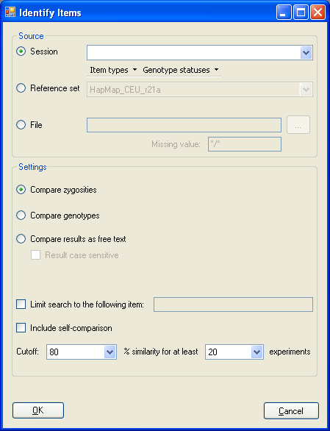
Figure 6 The Identify Items window.

Most settings are similar to that of the “Compare results” function and are not explained here. The ones which are different are described in the following table:

Setting | Explanation
Limit search to the following item | When the check box is checked, the program tries to match the item stated in the text box on the right to all items. When it is unchecked, the program tries to match all items to all items.
Include self-comparison | Indicates whether the program should also compare the items to themselves. This is of no meaning other than as a control that an item matches itself completely.
Cutoff: x% similarity for at least y experiments. | This works as a filter to get rid of false matches. The first figure indicates how similar the items must be for the match to be included in the report, and the second figure states that the comparison must be made over a certain number of experiments to be included. (Only matches where both these criteria are fulfilled are included in the report.)

The report starts with a list of all comparisons which passed the cutoff. Each row in the list contains the name of the two items which have been compared, how many experiments that were considered to be identical for the two items, and finally how many experiments that were compared for the two items. The list is sorted so that the fraction of identical experiments (identical experiments divided by compared experiments) is in descending order. For comparisons where the fraction of identical experiments is the same, those with a larger number of compared experiments are sorted before those with fewer compared experiments.

The rest of the report contains figures which are explained under the “Compare results” function in this manual.

Options -> Preferences
Here you can set the user preferences which will be saved for your user as soon as they are changed. The table below explains each setting.
Setting | Explanation
Automatically refresh session | Determines whether all of the tests and statistic calculations should be redone as soon as there is a change made to a genotype or to any of the session settings. It is recommended that automatic refresh is always turned on, but it can be switched off when analyzing large data sets in order to avoid tedious recalculations. When switched off, refreshing has to be done manually.
Enable experiment filter | When the check box is checked, you can limit the number of rows displayed in the experiment list of a session window and set the field used for sorting and the sort order. This means that you can see e.g. the 1000 experiments with the lowest success rate without having to display all experiments in the list. When a report is saved, however, data is streamed directly from the database with this setting on so that all experiments are listed in the report. Note that when the experiment filter is enabled, you cannot sort the experiments in the list by clicking on the column headers. When the check box is unchecked, all experiments are showed in the experiments list and you can sort them by clicking on the column headers.

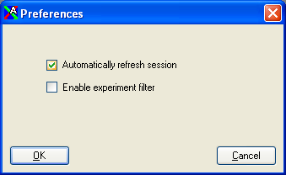

Figure 7 The “Preferences” dialog.

The session window
The session window represents a session, i.e. a data set analyzed using certain settings. The window has one list for experiment statistics, one list for result sample/individual statistics, and one list for control statistics.

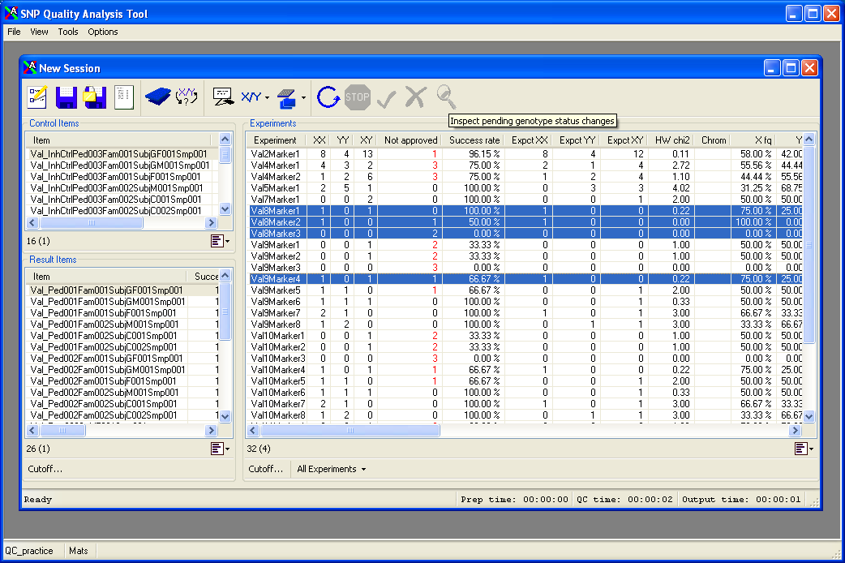

Figure 8 The session window contains three lists, one for controls, one for result samples/individuals, and one for SNP markers or assays. At the top of the window is a toolbar menu with shortcut buttons for some of the menu alternatives in the main window.

Special list features
All (or almost all) lists in the program have some special features to facilitate the handling of large amounts of data. One is the row counter present in the bottom left part of the list, where the first number represents the total number of rows in the list, and the number within parenthesis shows how many selected rows there are in the list.

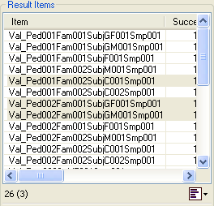

Figure 9 At the bottom of each list there is an indication for how many rows there are in the list, as well as how many of the rows which have been selected.

There is also a button in the bottom right part which produces a menu when being clicked on.

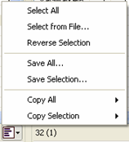

Figure 10 When the menu button is clicked, a menu appears where you can select different actions to perform on the list.

The menu alternatives are described here:

Select all
This menu alternative selects all rows in the list.

Select from file
Using this menu alternative, you can select items in the list by providing a text file which contains the text of the first column in the list for those rows which should be selected. If e.g. the first column in a list contains marker names, and you want to select the rows with markers named marker1, marker23 and marker31, you can use “Select from file” and provide a file with the following contents:

marker1
marker23
marker31

Reverse selection
This menu item unselects the selected rows and selects the unselected rows.

Save all
When this menu alternative is selected, the whole list is saved to a tab-delimited text file.

Save selection
This menu alternative saves the selected rows to a tab-delimited text file.

Copy all -> with column names
Use this menu item to copy the whole list to the clipboard, including the column names.

Copy all -> without column names
Use this menu item to copy the whole list to the clipboard, but leaving out the column names.

Copy selection -> with column names
This menu alternative copies the selected rows to the clipboard, and includes the column names.

Copy selection -> without column names
This menu alternative copies only the selected rows to the clipboard.

Experiments
The experiment list shows all SNP markers or assays in the dataset along with lots of statistics for each experiment. Below is a table with descriptions of each column.

Column | Description
Experiment | The name of the marker or assay.
XX | The number of the first type of homozygote among approved results.
YY | The number of the second type of homozygote among approved results.
XY | The number of heterozygotes among approved results.
Not approved | The number of results which were not approved, i.e. either had no genotype call (“N/A”) or failed in any of the duplicate tests or the inheritance test.
Success rate | The number of items (sample or individual) with an approved result compared to the number of items for which genotyping has been attempted for this experiment.
Expct XX | The expected number of the first type of homozygote assuming Hardy-Weinberg equilibrium.
Expct YY | The expected number of the second type of homozygote assuming Hardy-Weinberg equilibrium.
Expct XY | The expected number of heterozygotes assuming Hardy-Weinberg equilibrium.
HW chi2 | The χ² test statistic value for deviation from Hardy-Weinberg equilibrium.
Chrom | The chromosome name for the marker.
X fq | The fraction of alleles of the first type.
Y fq | The fraction of alleles of the second type.
Dupl failed item | The number of items which failed in the duplicate test.
Dupl tested item | The number of items tested in the duplicate test.
Item validtn | The number of items tested in the duplicate test, compared to the number of items for which genotyping has been attempted for this experiment.
Item mismatch | The number of items which failed in the duplicate test, compared to the number of items tested in the duplicate test.
Inh failed item | The number of items belonging to families which failed the inheritance test.
Inh tested item | The number of items belonging to families tested in the inheritance test.
HW failure | Indicates whether the Hardy-Weinberg χ² value for the SNP is above (failed) or below (passed) the limit specified in the session settings.
Rejected gt | The number of genotype results which have been manually rejected.
Inh ctrl failed item | The number of items belonging to families which failed the inheritance test for controls.
Inh ctrl tested item | The number of items belonging to families tested in the inheritance test for controls.
Blank ctrl failed item | The number of items which failed the blank test for controls.
Blank ctrl tested item | The number of items tested in the blank test for controls.
Homozyg ctrl failed item | The number of items which failed the homozygote test for controls.
Homozyg ctrl tested item | The number of items tested in the homozygote test for controls.

When the preferences setting “Enable experiment filter” is checked, you can select the maximum limit for the number of experiments shown in the list, and how the experiments should be sorted before they are displayed. This can be very useful when the data set contains a large number of experiments.

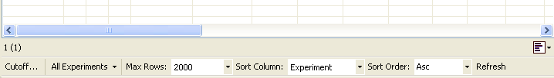
Figure 11 When experiment filtering is enabled in the preferences, it is possible to filter the experiments before they are displayed in the list.

The experiment menu
When one or more experiments are selected in the experiment list and the right mouse button is clicked, a menu appears where you can choose different actions for the selected experiments.

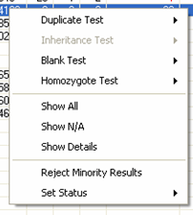

Figure 12 This figure shows the menu which appears when right-clicking on items in the “Experiments” list.

The menu alternatives are explained below.

Duplicate test -> Show failed/Show passed/Show tested
This menu alternative lists all genotype results from items which failed/passed/were tested in the duplicate test.

Inheritance test -> Show failed/Show passed/Show tested/Show failed trios
This alternative lists all genotype results from items which failed/passed/were tested in the inheritance test. The “Show failed trios” alternative lists all trio/duo tests (which form the basis for whether a whole family should be failed) together with the number of failures for each trio/duo in the selected experiments.

Blank test -> Show failed/Show passed/Show tested
Here, all genotype results from items which failed/passed/were tested in the blank test are listed.

Homozygote test -> Show failed/Show passed/Show tested
This menu alternative shows all genotype results from items which failed/passed/were tested in the homozygote test.

Show all
This menu item lists all genotype results for the selected experiment(s).

Show N/A
The menu item shows all results with no genotype call.

Show details
The menu item shows some statistics for all items but for the selected SNP marker only.

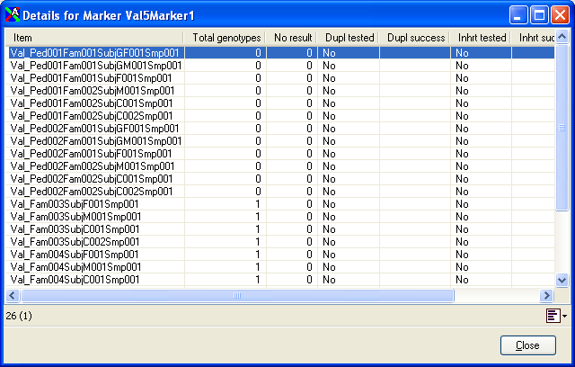

Figure 13 Details for a single SNP marker.

The table below explains the different columns in the list shown.

Column | Description
Item | The name of the sample or individual, depending on the setting.
Total genotypes | The number of results for this item and the selected experiment.
No result | The number of results without a genotype call.
Dupl tested | Indicates whether the item was in the duplicate test.
Dupl success | If the item was in the duplicate test, this column indicates whether the duplicate test was successful.
Inhrt tested | Indicates whether the item participated in the inheritance test (only in individual mode).
Inhrt success | If the item participated in the inheritance test, this column indicates whether the inheritance test was successful.
Approved result | Indicates whether the item has a genotype result which has passed all tests for the selected experiment.

Reject minority results
By using this menu alternative, you can take a majority decision for items which have been genotyped more than once for the same experiment but with inconsistent results. When the menu item is selected, a dialog prompts you to set the percentage of “votes” required for a majority decision.

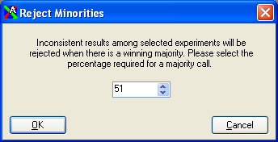

Figure 14 The “Reject Minorities” dialog.

Example 1: one sample has been genotyped four times with the results G/G, G/T, N/A and G/T. To begin with, only the results with a genotype call are counted, so we are left with G/G, G/T and G/G. Setting the limit to 66% in this case will reject the G/T genotype, because G/G wins with a 2/3 ≈ 66.67% majority. However, setting the limit to 67% will not let G/G win, because 66.67 < 67.00.

Example 2: one sample has been genotyped three times with the results G/G, G/T and T/T. Since there is not a majority for any of the results, no results will be rejected and no result will win no matter what the limit is set to.

Set status
This menu option changes the status of all results from the selected experiment(s).

Result Items
The result item list shows all samples or individuals (depending on the setting) which are part of the selected data set and which are not controls. The following table explains the different columns in the list.

Column | Description
Item | The name of the sample or individual (depending on the setting).
Success expm | The number of experiments for which this item has an approved genotype, compared to the number of experiments for which there has been genotyping attempts for this item.
Success nf expm | The number of experiments for which this item has an approved genotype, compared to the number of non-failed experiments for which there has been genotyping attempts for this item. A non-failed experiment is an experiment which has an approved result for at least one item.
Total gt | The total number of genotype results for this item.
No result gt | The number of results without a genotype call (N/A).
Failed dup expm | The number of experiments for which this item failed in the duplicate test.
Failed inh expm | The number of experiments for which this item failed in the inheritance test.
Failed HW expm | The number of experiments for which this item failed in the Hardy-Weinberg test.
Rejected gt | The number of results which have been manually rejected.
Chr X warn expm | The number of experiments on the X chromosome which were heterozygous in a male item (requires that the “Detect human X chromosome” setting is switched on).

Cutoff
This button can be used to reject all results from items with too low experiment success rates. When the button is clicked, a dialog appears where you can set the success rate limit and the type of success rate for which the cutoff should be applied. All results from items with a success rate equal to or below the selected rate will be rejected.

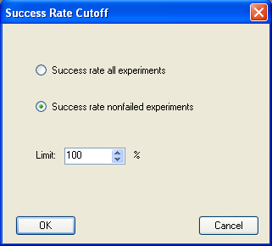

Figure 15 Selecting a success rate cutoff for items.

The result item menu
If you click on the right mouse button with one or more items selected, a menu will appear.

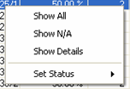

Figure 16 A menu appears when right-clicking on items.

The menu items are explained below.

Show All
All results from the selected items will be shown when this alternative is selected.

Show N/A
This option shows all results without a genotype call.

Show details
The alternative brings up an overview of how the selected items performed for each different experiment. The following table explains each column in the list.

Column | Description
Experiment | The name of the marker or assay.
Total genotypes | The total number of results from this experiment for the selected item.
No result | The number of results without a genotype call (N/A).
Dupl tested | Indicates whether a duplicate test was performed for the experiment and the selected item.
Dupl success | If a duplicate test was performed, this column indicates whether the test was successful.
Inhrt tested | Indicates whether an inheritance test was performed for the experiment in the selected item (only relevant in individual mode).
Inhrt success | If an inheritance test was performed, this column indicates whether the test was successful.
ChrX tested | Indicates whether a test for heterozygosity in male items on the X chromosome was performed (requires that the “Detect human X chromosome” setting is switched on).
ChrX success | If the heterozygosity test in male items on the X chromosome was performed, this column says if the test was successful.
Approved result | Indicates whether there is a result which has passed all tests for this experiment in the selected item.

Set status
Changes the status of all results from the selected item(s) to “load” or “rejected”.

Control Items
The “Control Items” list shows all control items included in the data set, and how they did in the quality tests for controls.

The following table explains the different columns.

Column | Description
Item | The name of the sample or individual.
Failed expm | The number of experiments with failed results in the quality tests peformed on the control item.
Tested expm | The number of experiments which were tested in the quality tests on the control item.

The control items menu
If you click on the right mouse button with one or more control items selected, a menu will appear.

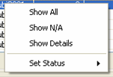

Figure 17 This menu appears when right-clicking on control items.

Show All
All results from the selected items will be shown when this alternative is selected.

Show N/A
This option shows all results without a genotype call.

Show details
The alternative brings up an overview of how the selected control item performed for each different experiment.

Column | Description
Experiment | The name of the marker or assay.
Tests | The number of tests of the type associated with the control item which has been performed.
Failures | The number of tests which failed.

Set Status
This menu alternative changes the status of all results from the selected control items to “load” or “rejected”. Note that blank controls and homozygote controls are tested regardless of the genotype status, whereas the inheritance control skip rejected genotypes.

Menu items connected to the active session

File -> Close Session
This menu alternative closes the active session.

File -> Save Session

When this menu item is selected, the “Save as” dialog is shown where you can enter a name and description for the session and select under which project the session should be saved.

File -> Save Report
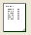
This menu item brings up the “Report” form.

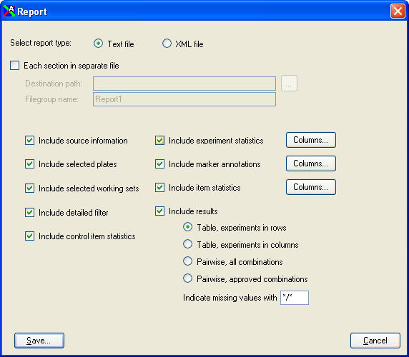

Figure 18 In the “Report” window, it is possible to specify what sections to include in the report.

First select the type of file you would like to save. Choose text file to save the report as a tab delimited text file, or use XML file if the report should be processed by some other program which supports the XML format.

Use the check boxes to specify which sections should be included in the report. By clicking the “Column” buttons you can also specify in detail which information that will be included in each section.

For text files, the report can be split into separate files for each section by checking the “Each section in separate file” check box. Then you need to specify a path to where the files should be stored, and a file group name before clicking on the save button. The file group name is used as a basis to form the names of all the section files.

File -> Approve Session

This menu alternative is similar to “Save Session” in that it shows the “Save as” dialog and lets you save the active session. The differences are two: 1) When a session is saved as approved, it is no longer possible to change (reject) any of the results included in the approved session unless the session is unlocked. 2) Each approved genotype result in the session is indicated as approved in the database.

After a session has been approved, the session will automatically close in order to prevent further changes to the results in the session. All approved sessions are indicated with a small padlock on the icon when you browse for sessions to load using the File -> Open Session menu alternative.

View -> Show Results -> Table, Experiments in Rows
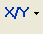
A table is brought up when this menu item is selected, which shows all approved genotype results with one row for each experiment and one column for each item.

View -> Show Results -> Table, Experiment in Columns
This menu alternative shows all approved genotype results with one row for each item and one column for each experiment.

View -> Show Results -> Pairwise, Approved Combinations
In this alternative, the approved genotype results are shown for each pair-wise combination of items and experiments. Only the combinations which have an approved result are included so that there are no blank spaces for combinations without approved results.

View -> Show Results -> Pairwise, All Combinations
In this alternative, the approved genotype results are shown for each pair-wise combination of items and experiments. All pair-wise combinations are included, but only approved results are shown and the result fields for combinations without approved results are left blank.

View -> Show Marker Annotations

By selecting this menu item, you can view any annotations which have been stored in the database for the markers in the selected data set. When the menu item is selected, a form is shown where you can select what type of annotations you want to view.

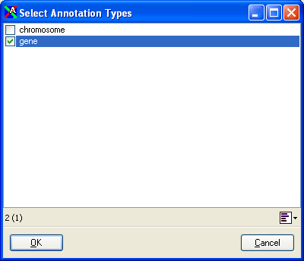

Figure 19 When showing marker annotations, you first need to select the types of annotations to show.

After the annotation types have been selected, a list is shown with the SNP markers and corresponding annotations.

View -> Show Session Contents -> Plates

This alternative shows a list of the plates which were selected for the current session.

View -> Show Session Contents -> Working Sets
A list of the working sets which were selected for the current session is shown.

View -> Show Session Contents -> Detailed Filter
Use this alternative to show a list of all selected samples/individuals/assays/markers used to further restrict the selection of data.

View -> Show Pending Status Changes

If you have made status changes to any of the genotypes (such as rejections) which have not yet been submitted, you can use this option to view those changes before submitting.

Tools -> Inspect Plates

With this alternative you open a form where each plate in the dataset can be examined individually. Note that only data in the currently selected data set are included, so if a plate and a sample working set were selected when the session was started, only the results from the samples in the working set will be included when you examine the plate. Please see “The plates window” for more information.

Tools -> Pick Rerun Items

When this menu item is selected, a form is shown where you can select criteria for automatically producing a list of samples/individuals which need to be genotyped again.

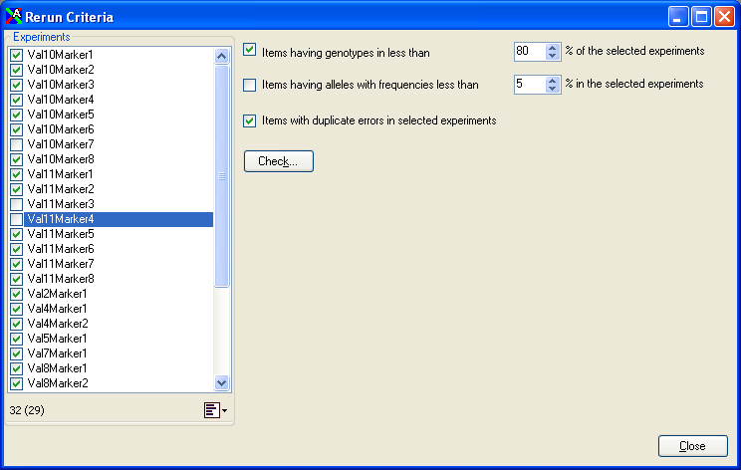

Figure 20 In the “Rerun Criteria” window you can select criteria for automatically including samples/subjects in the rerun list.

Check “Items having genotypes in less than x% of the selected markers” to include samples/individuals for which a lot of results are missing among the experiments checked in the list on the left-hand side of the form. The reason for missing genotypes can be either due to failure in genotyping, failure in the quality tests or simply because they have not yet been genotyped for all experiments.

Check “Items having alleles with frequencies less than x% in the selected experiments” to include items with rare alleles for the experiments checked in the left-hand side of the form.

Check “Items with duplicate errors in selected experiments” to include samples/individuals with failed results in the duplicate tests for the experiments checked in the list to the left.

Click on the “Check” button to open a new window with all items listed, where the items included by the selection criteria are checked.

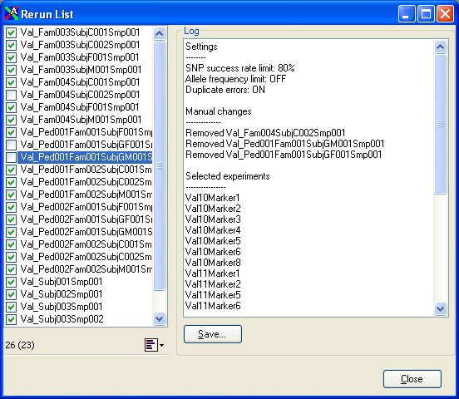

Figure 21 In the left part of the “Rerun List” window is a list of items. The checked items are marked for repeated genotyping. To the right is a log which helps you keep track of the settings and manual changes made to the rerun list.

You can also manually select or deselect items before saving the items to a file by using “Save checked” in the list menu which appears when you click on the menu button. Both the criteria for automatic selection and any manual changes are recorded in the text box to the right. You can save this text in a file by clicking on the “Save” button.

Options -> Session Settings

Selecting this menu item opens the session settings form, where you can alter the settings for the currently active session. You can have many open sessions at once, and they can all have different settings.

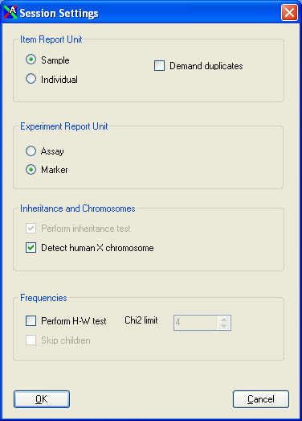

Figure 22 The “Session Settings” window.

The session settings window
Here is a list of the different alternatives and what they mean.

Item Report Unit
As mentioned earlier, the program can report the results by sample or by individual. The difference is that several samples can come from the same individual. When the program is in sample mode, each sample is treated separately. On the other hand, when the program is in individual mode, all results belonging the same individual are merged.

Another setting which has to do with how the results are reported is the “Demand duplicates” check box. Checking this box means that only results from items which have been tested in and passed the duplicate test will be approved. Thus, results from samples or individuals which have been genotyped only once, or which have only one genotype call, will not be used as valid results. When the box is unchecked, one genotype call will suffice for a valid result.

Experiment Report Unit
In a similar manner to the item report unit, experiment report unit determines whether the results should be grouped by markers or by assays. There can be many assays for the same marker, and when the experiment report unit is set to “assay”, each assay is treated individually. This also means that for example the duplicate test only tests for duplicates within the same assay. Therefore, “marker” is the normal setting, but to investigate how different assays for the same marker performed compared to each other, the “assay” setting is useful.

Inheritance and chromosomes
For this group of settings, the “Perform inheritance test” check box controls whether an inheritance test should be performed when there is family information stored in the database. The setting can only be altered in individual mode. The “Detect human X chromosome” setting determines if markers annotated with an “X” for an annotation type called “chromosome” in the database should be treated as a human X chromosome in the inheritance test, and also if the warning for heterozygote genotypes on X chromosomes for male items should be activated.

Frequencies
Check the “Perform H-W test” check box if you want results from markers which have a χ² value above the selected limit to be excluded from the approved results. The “Skip children” check box determines if subjects which have been stored as children in the database should be excluded from the Hardy-Weinberg χ² test or not. Note that the latter setting only affects the χ² value and not any other statistics or results.

The plates window

The selection tab
Here you see a physical representation of the plate, where wells having genotypes in the current data set are shown in a light blue color, whereas empty wells (or wells with genotypes excluded from the current data set) are white.

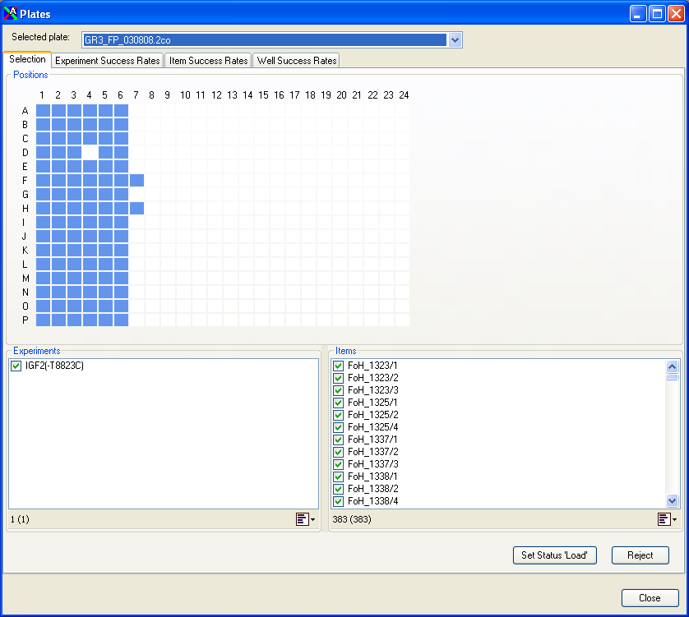

Figure 23 The picture shows the “Plates” window with the “Selection” tab open. In this tab you can select results which should be rejected using a combination of wells, experiments and items.

You can select a single well by clicking on it, multiple wells by holding down the CTRL key while clicking on the wells, or select a rectangular area of wells by holding down the SHIFT key and clicking on the well in one corner of the area followed by the well in the diagonally opposite corner of the area.

By selecting wells in the top part of the form and any number of experiments and items in the bottom part of the form, you can reject the results from the selected items genotyped for the selected experiments in the selected wells by clicking the “Reject” button. When “Reject” is clicked you can confirm or cancel the rejection. You can later set the genotypes back to the “load” status by clicking the “Set Status ‘Load’” button. This works in the same way as rejection, i.e. only genotypes for the combination of selected wells, experiments and items are set to “load”.

The experiment success rates tab
In this tab you will see a list of the genotyping success rates in the plate for the different assays/markers. The term “genotyping success” means “How many results were given a genotype call compared to the total number of results”. By clicking the “Cutoff” button at the bottom of the tab, you can reject all results for poorly working experiments within the plate by selecting a cutoff value for the genotyping success rate required for the results not to be rejected. All results from experiments with a genotyping success rate below or equal to the selected cutoff will be rejected. Note that controls are excluded from the calculation of genotyping success.

The item success rates tab
Here you will see a list of the genotyping success rates in the plate for the different samples or individuals. Click “Cutoff” to discard all results for poorly working items within the plate by selecting a cutoff value for genotyping success rate. When using the “Cutoff” button, all results from items with a genotyping success within the plate below or equal to the selected value will be rejected.

The well success rates tab
This tab contains genotyping success rates in the plate for the different wells. Click “Cutoff” to discard all results for poorly working wells by selecting a cutoff value for genotyping success rate. When using the “Cutoff” button, all results from wells with a genotyping success below or equal to the selected value will be rejected.

Special toolbar buttons
Some of the toolbar buttons at the top of the session form are not available as menu items in the main window.

Processing control toolbar buttons
The “Refresh” button is used for manually initiating recalculation of all the statistics in the current session. This is only necessary when the automatic refresh option in the preferences has been switched off.



Figure 24 The “Refresh” button.

The “Stop” button can be used to cancel an ongoing calculation. When the button is clicked during processing of the results, the calculations are immediately aborted and the session window is left with blank lists for experiments and items. If you want to reinitiate the calculations again, click on the “Refresh” button.

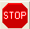

Figure 25 The “Stop” button.

Status submission toolbar buttons
After the status has been changed for genotypes (i.e. when genotypes have been rejected or the status has been changed back to “load” from “rejected”), the changes must be submitted to the database in order for the changes to be saved permanently. To save the changes, click on the submit button.



Figure 26 The “Submit” button.

If you have made status changes which you want to undo, you can click on the “Clear” button. It is only possible to undo changes made since the last submission.

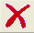

Figure 27 The “Clear” button.

